1. **Create Hub and Spoke network Establish Spoke to Spoke connectivity.**

**Ans:**

* **Step 1: Create the Hub VNet**
* Create a Virtual Network:
* Go to the Azure portal.
* Navigate to "Create a resource" > "Networking" > "Virtual Network".
* Provide the necessary details such as the name, address space, and resource group.
* Create the VNet.
* **Step 2: Create Spoke VNet**
* Create Multiple Spoke VNets:
* Follow the same steps as creating the Hub VNet but with different address spaces.
* For each spoke, ensure the address space does not overlap with the Hub VNet or other spokes.

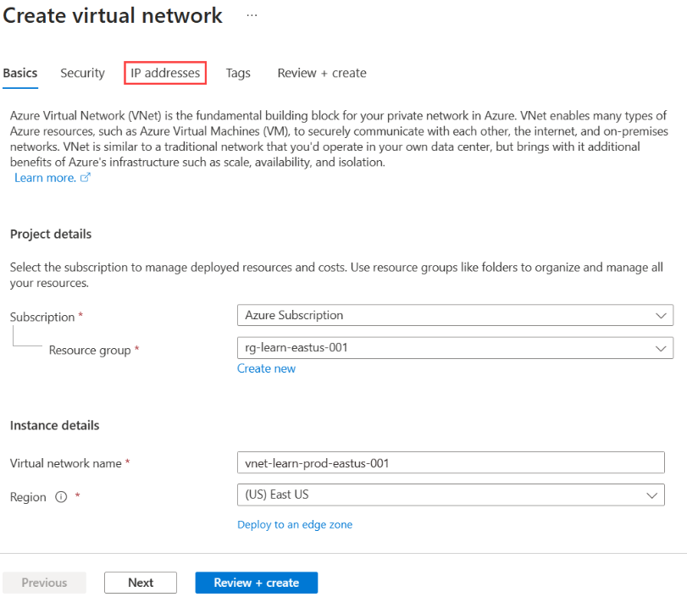

* **Step 3: Peer the Spoke VNets with the Hub VNet**
* Peer Each Spoke to the Hub:
* Go to the Hub VNet.
* Click on "Peerings" and add a new peering.
* Select the spoke VNet you want to peer with.
* Enable "Use remote gateways" and "Allow gateway transit" for the hub VNet.
* For each spoke VNet, ensure "Allow forwarded traffic" and "Allow gateway transit" are enabled.

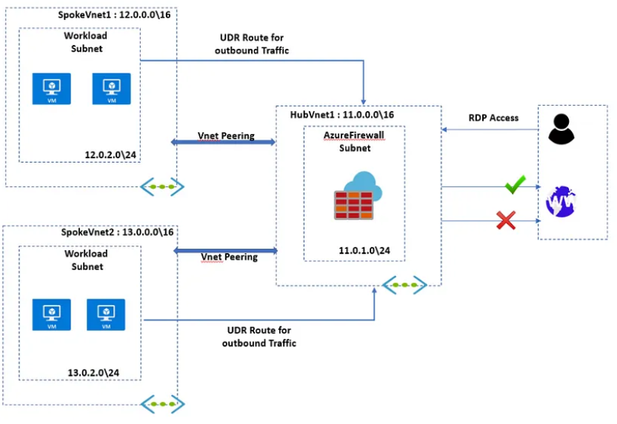

* **Step 4: Configure Spoke-to-Spoke Connectivity**
* Route Traffic Through the Hub:
* Create route tables for each spoke VNet.
* Add routes that direct traffic destined for other spokes through the hub.
* Associate the route tables with the subnets in each spoke VNet.
* **Step 5: Verify Connectivity**
* Create Virtual Machines in Each VNet:
* Deploy VMs in the subnets of the hub and spoke VNets.
* Ensure network security groups (NSGs) allow communication between the VNets.
* Test connectivity between VMs in different spokes via the hub.

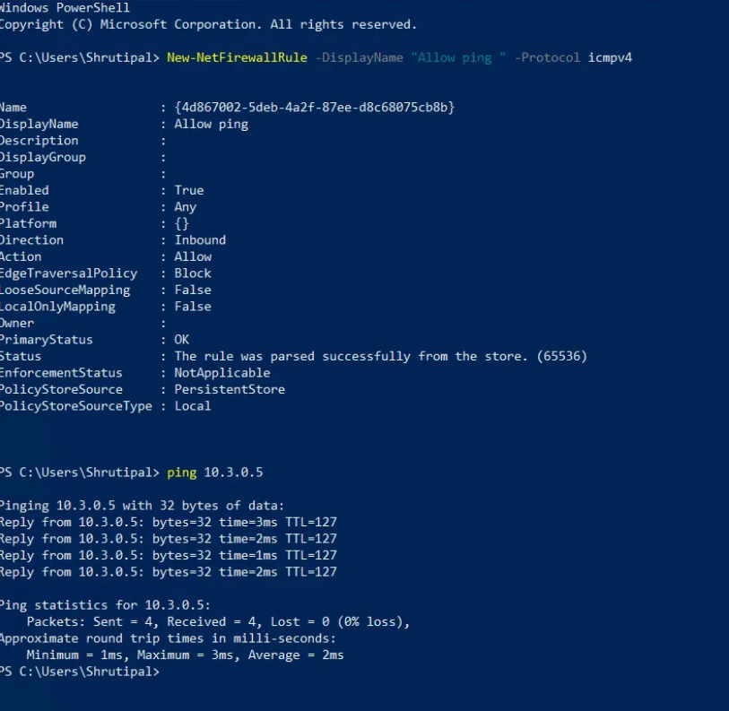

* **Step-by-Step instructions for the ARM Template:**

**Step 1 : Create a Resource Group:**

* Go to the Azure portal.
* Navigate to "Create a resource" > "Resource group".
* Provide a name and region for the resource group.

**Step 2 : Deploy the ARM Template:**

* Go to the resource group you created.
* Click on "Deploy a custom template".
* Select "Build your own template in the editor".
* Copy and paste the ARM template code above.
* Save and deploy the template.

**Step 3 : Verify the Deployment:**

* Once the deployment is complete, you should see the Hub VNet, Spoke VNets, and the peering configurations in the Azure portal.
* Verify the connectivity by creating VMs in the Hub and Spoke VNets and checking the network routes and connectivity between them.